!! SAVE THE DATE !!
Help us to make history, the first time ever an official
DOGO ARGENTNIO SHOW
in Sweden
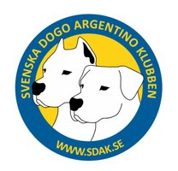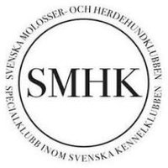
When: 2024-07-27
Where: Gränna
Judge: Eva Pastuchova, specialjudge from Slovakia.
Kennel Prefix “De Los Escorpiones Blancos”
Stay updated via SDAK website www.sdak.se , Facebook and Instagram. More information will come later. If you have any questions, please email styrelsen@sdak.se
This weekend July 27-28, you have the chance to win 3 certificates in 2 days! with your Dogo Argentino, in addition to our Breed Special, you have the opportunity to exhibit in our Special club Swedish Molossers and the herding dog club.
